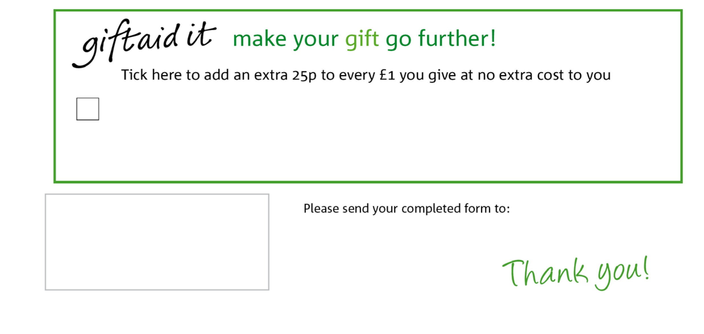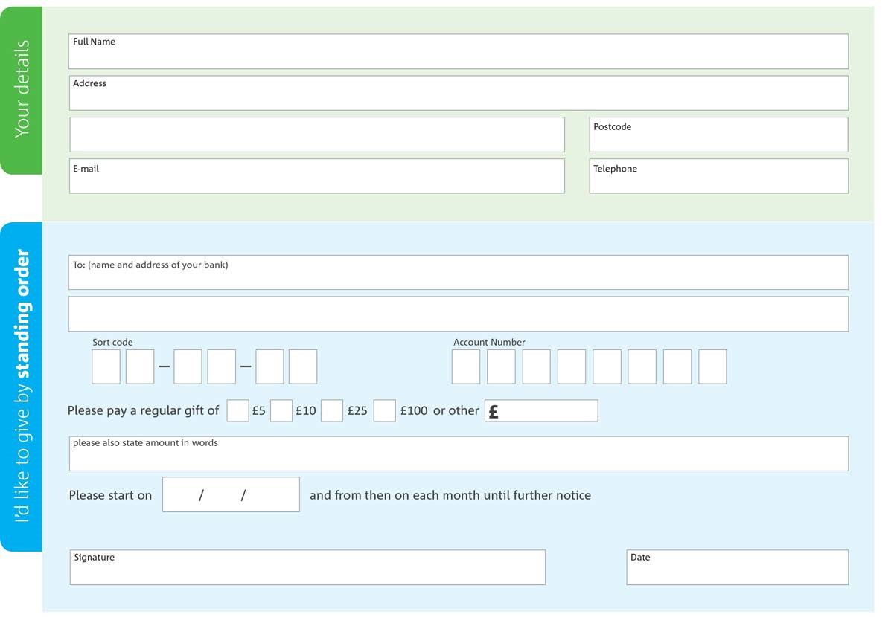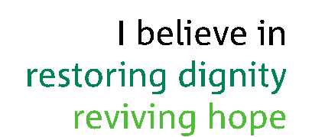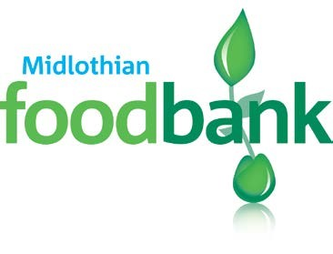

www.midlothian

.foodbank.org.uk

to midlothian

foodbank each month

,

This cancels any previous standing order i

nstructions to midlothian

foodbank

Yes, I pay tax in the UK. Please treat all donations I make or have made to

midlothian

foodbank for

the past four years as gift aid

donations until further notice.

I confirm I have paid or will pay an amount of Income Tax and/or Capital Gains Tax for each tax year (6 April to 5 April) that is at least

equal to the amount of tax that all the charities or Community Amateur Sports Clubs (CASCs) that I donate to will reclaim on my gifts

for that tax year. I understand that other taxes such as VAT and Council Tax do not qualify. I understand the charity will reclaim 25p of

tax on every £1 that I give.

Bank of Scotland

:

47

High Street, Dalkeith,

80:06:29

00282963

Reg. Charity No:

SC004673

| Reg. in

Scotland

Gorebridge Parish Church, 96 Hunterfield Rd, Gorebridge, EH23

4

TT

Tick i

f you would prefer NOT to receive e

-

news