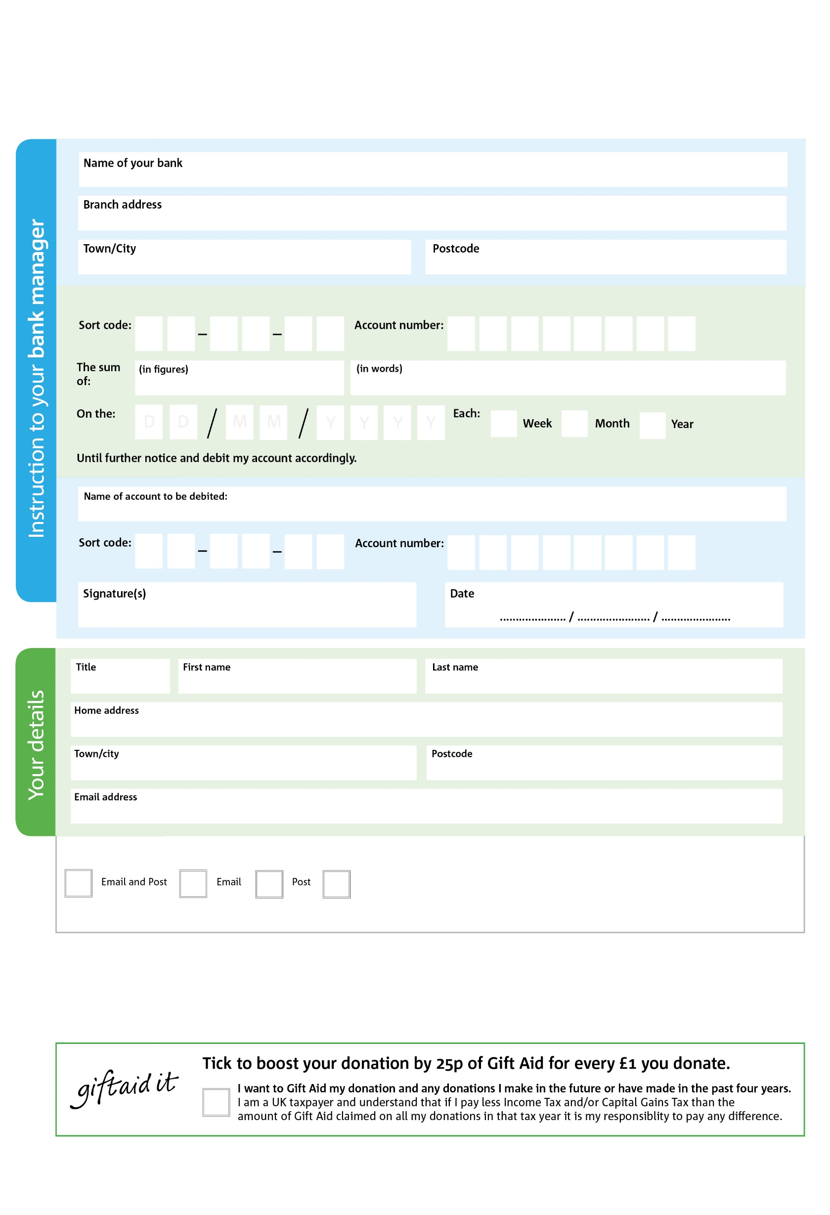

POSTAL ADDRESS: Midlothian Foodbank, 96 Hunterfield Road, Gorebridge, Midlothian, EH23 4TT

You can change your preferences any time by contacting us on [07789 173276](tel:07789%20173276) or emailing us at [janiceburns@midlothian.foodbank.org.uk](mailto:janiceburns@midlothian.foodbank.org.uk)

6

**Please pass this form onto the foodbank, using the foodbank’s address at the bottom, who will save a copy for their records. They will then send it onto your named bank or building society.**

6

V

4

V

8

V

0

V

0

V

8

V

1

V

0

6

2

2

0

8

We would love to keep you up to date with information about Midlothian Foodbank. Please tick your preference:

I do not wish to receive future communications from Midlothian Foodbank

Please pay Midlothian Foodbank,

**Data protection**

Midlothian Foodbank is committed to protecting your privacy and will process your personal data in accordance with the Data Protection Act 1998. Midlothian Foodbank collects information to keep in touch with you and supply you with information relating to our work. Midlothian Foodbank will never sell or pass your details to anyone who isn’t directly working on our behalf.

**Standing Order Mandate**

**midlothian.foodbank.org.uk**

Reg. Charity No: SC004673 | Reg. in Scotland

You can change your preferences any time by contacting us on XXXXXXXXXXX or emailing us at XXXX@XXXXXXXXXX.foodbank.org.uk

I do not wish to receive future communications from XXXXXX Foodbank